**Text Editor**



**Session: 2023 – 2027**

**Submitted by:**

Khola Raouf 2023-CS-156

**Supervised by:**

Nazeef ul Haq

Department of Computer Science

**University of Engineering and Technology**

**Lahore Pakistan**

Table of Contents

List of Figures: 3

List Of Tables 4

1.1 Overview: 5

1.1.1 Introduction: 5

1.1.2 Motivation: 5

1.1.3 Objectives 6

1.1.4 Target Audience: 6

1.1.5 Operational Details: 6

1.2 Use Cases: 7

1.2.1 File Menu: 8

1.2.2 Edit Menu: 8

1.2.3 View Menu: 8

1.2.4 Theme: 8

1.2.5 Menu Bar: 8

1.2.6 Status Bar: 9

1.3 Wire Frames: 9

1.3.1 File Menu: 9

1.3.1.1 New File: 9

1.3.1.2 Open File: 11

1.3.1.3 Save File: 11

1.3.1.4 Save As File: 12

1.3.1.5 Exit: 13

1.3.2 Edit Menu 14

1.3.2.1 Cut 14

1.3.2.2 Copy 15

1.3.2.3 Paste 16

1.3.2.4 Undo 17

1.3.2.5 Redo 18

1.3.2.6 Select All 19

1.3.2.7 Clear 20

1.3.2.8 Find 21

1.3.3 View Menu Functions 21

1.3.3.1 View Status Bar 21

1.3.3.2 View Menu Bar 21

1.3.3 Status Bar: 23

1.3.3.1 Count Number of Words 23

1.3.3.2 Count Number of Characters: 23

1.4 Component Details: 23

1.4.1 File Menu: 23

1.4.2 Edit Menu: 23

1.4.3 View Menu: 24

1.4.4 Theme 24

1.4.5 Text Area: 24

1.5 Data Structures and Algorithms Implementation: 24

1.5.1 Text Area - Binary Search Tree (BST): 24

1.5.2 Undo/Redo - Stack: 25

1.5.3 Cut, Copy, Paste - Graph: 25

1.6. Future Improvements: 25

# **List of Figures:**

|  |  |  |  |
| --- | --- | --- | --- |
| Figure No. | Description |  | Page No. |
| Fig 1.1 | File Menu Overview |  | 7 |
| Fig 1.2 | New File Option |  | 8 |
| Fig 1.3 | Open File Option |  | 9 |
| Fig 1.4 | Save File Option |  | 10 |
| Fig 1.5 | Save As File Option |  | 11 |
| Fig 1.6 | Exit Application Option |  | 12 |
| Fig 2.1 | Cut Operation |  | 13 |
| Fig 2.2 | Copy Operation |  | 14 |
| Fig 2.3 | Paste Operation |  | 15 |
| Fig 2.4 | Undo Operation |  | 16 |
| Fig 2.5 | Redo Operation |  | 17 |
| Fig 2.6 | Select All Operation |  | 18 |
| Fig 2.7 | Clear Text Option |  | 19 |
| Fig 2.8 | Find Text Option |  | 20 |
| Fig 3.1 | Status Bar Overview |  | 21 |

# List Of Tables

|  |  |  |  |
| --- | --- | --- | --- |
| **Table** **No**. |  | **Description** | **Page** No. |
| Table 1 |  | File Menu Options | 22 |
| Table 2 |  | Edit Menu Options | 22 |
| Table 3 |  | View Menu Options | 23 |
| Table 4 |  | Theme Selector | 23 |
| Table 5 |  | Text Area | 23 |
|  |  |  |  |
|  |  |  |  |

# 1.1 Overview:

# 1.1.1 Introduction:

This project focuses on managing text-based documents through a user-friendly text editing application. In today’s digital age, creating and managing written content efficiently is essential for students, professionals, and writers. A text editor provides essential tools for creating, editing, formatting, and organizing text files. For example, in writing tasks such as reports or articles, users need features like text formatting, file management, and search functionality to enhance productivity and maintain content quality. The application supports a range of features including text customization, file operations, and theme customization. It ensures that users can perform tasks like formatting text, adjusting fonts, and exporting documents with ease. This simplifies text processing tasks while reducing manual effort and minimizing errors, making the application ideal for both personal and professional use.

## 1.1.2 Motivation:

Managing text-based documents manually, such as editing, formatting, and organizing files, can be a time-consuming and error-prone process. Users often spend significant time manually adjusting text, performing search operations, and managing file versions. This leads to inefficiencies, particularly when dealing with large documents or multiple files. The current manual approach lacks automation, making it cumbersome for users to keep track of changes, format text consistently, and maintain organization.

To address these issues, a text editor is developed that streamlines the process of document creation and management. This system leverages efficient algorithms and data structures to automate tasks such as text formatting, searching, and file management. By minimizing manual intervention, the application significantly reduces errors, enhances productivity, and provides an organized and user-friendly interface for editing and handling text documents.

## Objectives

1. **To Develop a Systematic and Comfortable Text Editing Application:** Create a user-friendly text editor that provides an intuitive interface, allowing users to comfortably create, edit, and manage text documents.
2. **To Develop an Error-Free System:** Ensure the text editor is robust and free from bugs or glitches. The application should handle tasks like text editing, saving, and searching seamlessly, providing a smooth user experience without crashing or producing incorrect results.
3. **To Test the Reliability of the System:** Evaluate the performance and reliability of the text editor by testing it under different conditions, such as handling large files, multiple open documents, and long editing sessions. The system should be dependable and function correctly without significant delays, crashes, or data loss.

## Target Audience:

The target audience for the text editing application includes:

1. **Students:** Students in various educational levels (high school, college, university) who require a tool for writing essays, reports, assignments, and research papers. The application provides a simple, effective, and distraction-free environment for their writing needs.
2. **Teachers and Educators:** Teachers who need to prepare lesson plans, assignments, and exams, as well as those who require tools for editing and grading written materials submitted by students.
3. **Writers and Authors:** Writers, journalists, and authors who regularly create, edit, and revise written content, benefiting from advanced text formatting, version control, and organization features.

## Operational Details:

This text editing application allows users to create, edit, and manage text documents efficiently. It offers a variety of features including text formatting, undo/redo options, and text search and replace functionality. Users can save, delete, and update documents, organizing them into folders for easy access. The system also supports exporting documents in various formats such as .txt, .docx, and .pdf for report generation or sharing. Additionally, users can customize the interface and adjust settings according to their preferences, ensuring a personalized and streamlined editing experience.

# Use Cases:

1. File Menu
   1. New File
   2. Open Existing file
   3. Save File
   4. Save as file
   5. Exit
2. Edit Menu:
   1. Cut
   2. Copy
   3. Paste
   4. Undo
   5. Redo
   6. Select All
   7. Clear
   8. Find
3. View Menu
   1. View Status Bar
   2. View menu Bar
4. Theme
   1. Select color of background
5. Menu Bar
   1. Font style
   2. Font size
   3. Bold
   4. Italic
   5. Underline
   6. Color of text
   7. Align(Left, Right, Center)
6. Status Bar
   1. Count no. of words
   2. Count no of characters

## 1.2.1 File Menu:

The **File Menu** provides essential document management functions. The **New File** option allows users to start a fresh document, while **Open Existing File** enables users to open previously saved documents. The **Save File** option ensures that any changes made to a document are saved, while **Save As File** allows users to save the document under a new name or location. The **Exit** option enables users to close the application, prompting them to save any unsaved work before closing, ensuring data is not lost.

## 1.2.2 Edit Menu:

The **Edit Menu** provides a range of text editing options to facilitate easy manipulation of content. The **Cut** and **Copy** options allow users to remove or duplicate selected text, while **Paste** lets users insert previously cut or copied text. The **Undo** and **Redo** options enable users to easily revert or reapply changes made to the document. **Select All** allows users to quickly select all content in the document, and **Clear** removes all text. The **Find** feature provides a search option to locate specific text within the document, improving text navigation and editing efficiency.

## View Menu:

The **View Menu** controls the visibility of various UI elements to enhance the user experience. The **View Status Bar** option allows users to display or hide the status bar at the bottom of the window, which can show useful information like word and character count. The **View Menu Bar** option enables or disables the visibility of the menu bar, allowing users to customize their workspace by showing or hiding different menus, creating a more streamlined or minimalistic interface based on their preferences

## Theme:

The **Theme** feature provides users with the ability to personalize the appearance of the editor by selecting the background color. Users can choose from a variety of colors to adjust the theme to their liking, enhancing the comfort and readability of the editor. This option allows for both aesthetic customization and practical improvements, such as reducing eye strain by selecting a darker or lighter background.

## Menu Bar:

The **Menu Bar** provides a comprehensive set of formatting tools to customize the text and document layout. Users can change the **Font Style** and **Font Size** to adjust the appearance of the text. The **Bold**, **Italic**, and **Underline** options allow for emphasizing or highlighting text, giving users control over how the document looks. The **Color of Text** option lets users change the font color to suit the document’s style. Additionally, the **Align** options (Left, Right, Center) allow users to adjust the alignment of text within the document, giving them full control over the layout.

## Status Bar:

The **Status Bar** provides real-time information about the document’s content and current status. It includes a **Word Count** feature that tracks the number of words in the document, allowing users to keep tabs on the length of their work. The **Character Count** feature tracks the number of characters in the document, which is useful for meeting specific character limits or requirements. The status bar continuously updates these counts as the user types or modifies the document, providing immediate feedback without the need to manually count words or characters.

# Wire Frames:

## 1.3.1 File Menu:

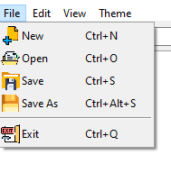

Fig no. ‎1.3‑1 File menu

This file menu contain basically handling the file functions like opening file, saving etc. further more given below.

### 1.3.1.1 New File:

This option allows the user to create a new, blank document in the editor. It resets the editor’s content area, providing a fresh workspace for the user.

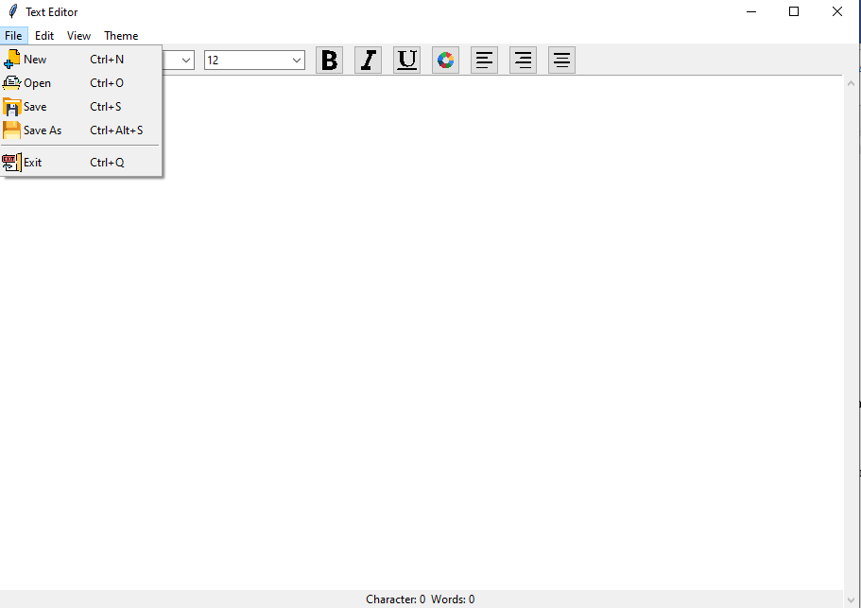

Fig no. ‎1.3‑2 New file

### 1.3.1.2 Open File:

This option allows users to open and edit an already saved file. The user can browse their system, select the file, and it will be loaded into the editor for further modifications.

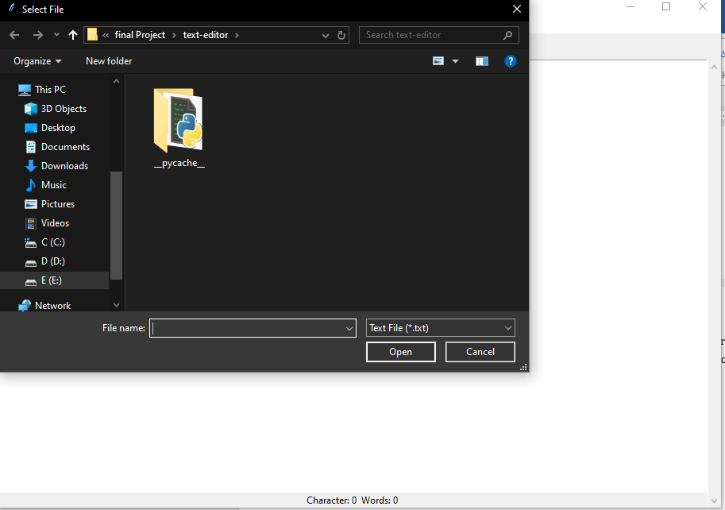

Figure 3 Open File

Figure 3 Open File

Fig no. 3 Open File

Fig no. 3 Open File

1.3.1.3 Save File:

This saves the current document in its existing location, preserving any changes made since the last save. If the file hasn't been saved before, it will prompt the user to choose a file location and name.

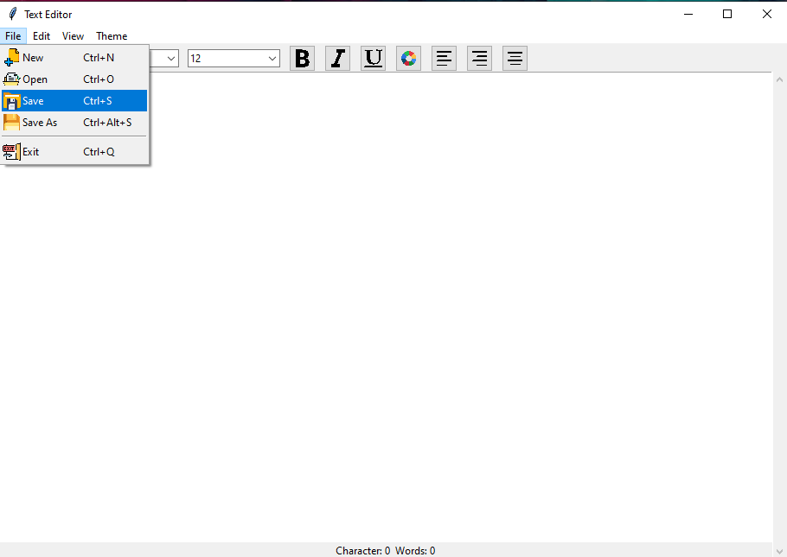

Fig no. 4 Save File

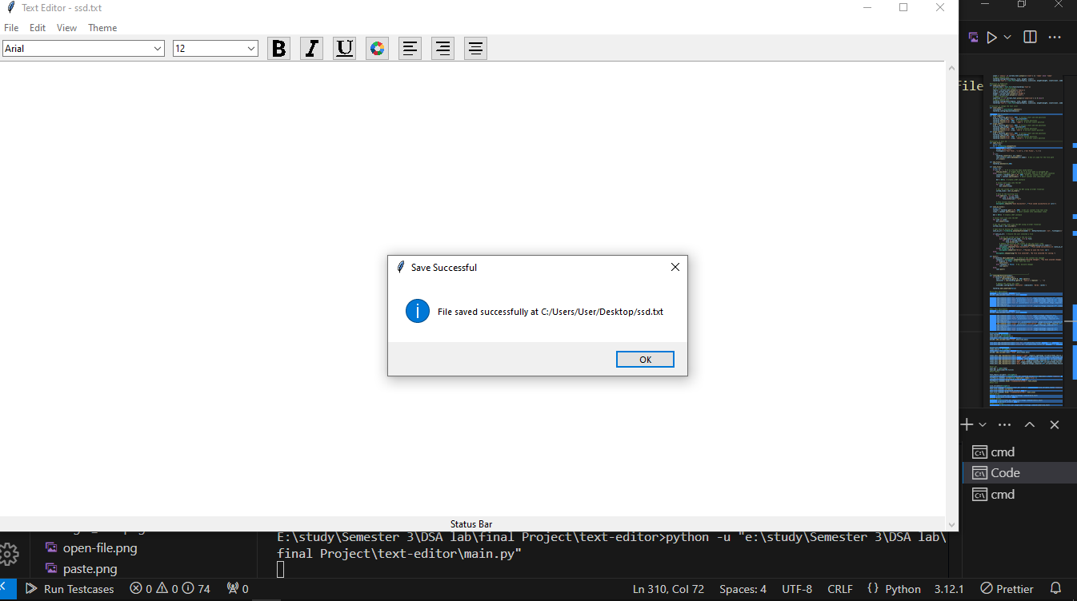

1.3.1.4 Save As File:

This option allows users to save the current document under a new name or location. This is useful for creating a copy of the document with a different name or saving it in a different format.

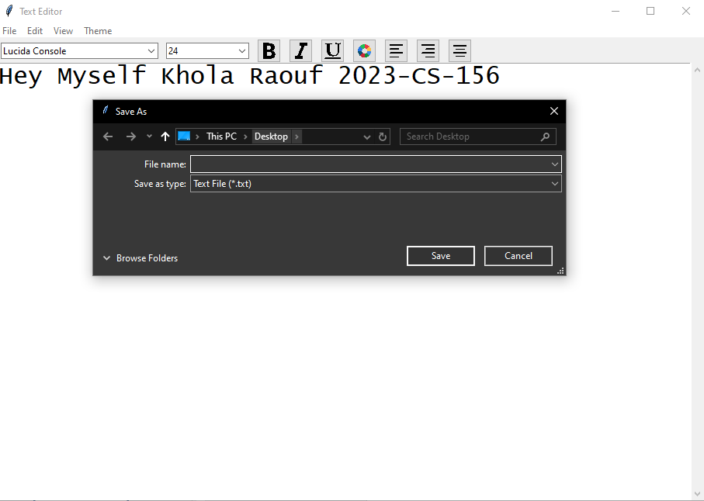

Fig no. 5 Save As File

1.3.1.5 Exit:

This closes the application. If there are unsaved changes, the system will prompt the user to save before exiting to avoid data loss. File Closed

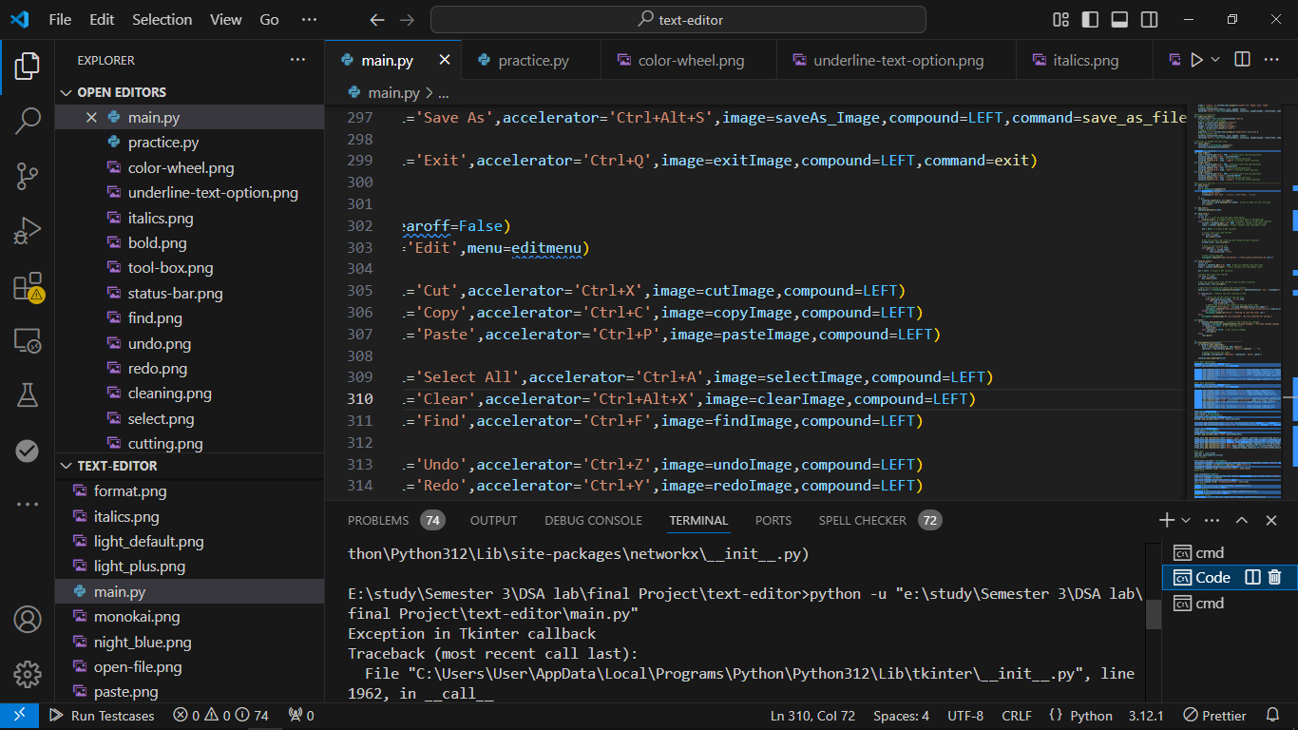

Fig no. 6 By clicking on Exit(closed)

## 1.3.2 Edit Menu

### 1.3.2.1 **Cut**

The "Cut" option removes the selected text or content from the document and places it in the clipboard, making it ready to be pasted elsewhere.

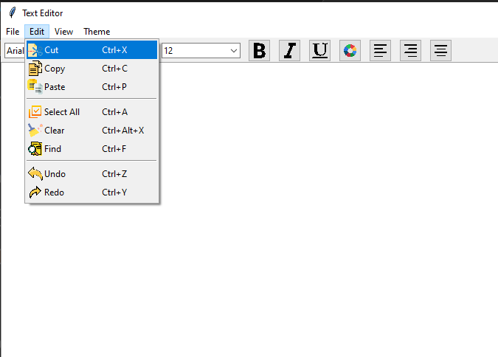

Fig no.7 Cutting text

### 1.3.2.2 **Copy**

This option copies the selected text or content to the clipboard without removing it from its original location, allowing the user to paste it multiple times if needed.

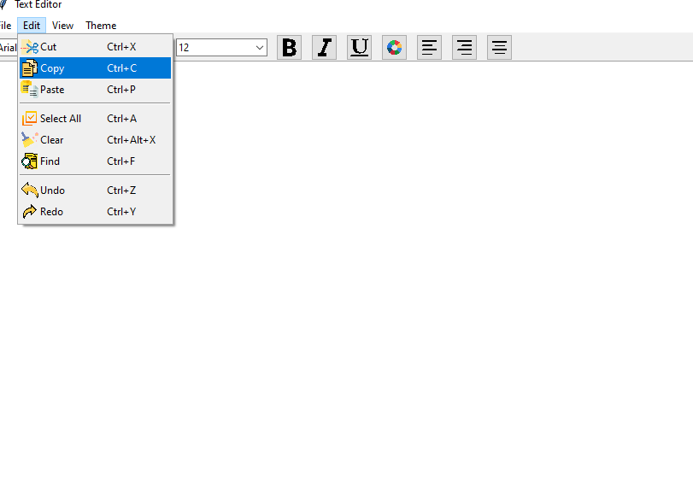

Figure 7 Copy

### 1.3.2.3 **Paste**

"Paste" inserts the content stored in the clipboard into the document at the current cursor position. The user can paste copied or cut text.

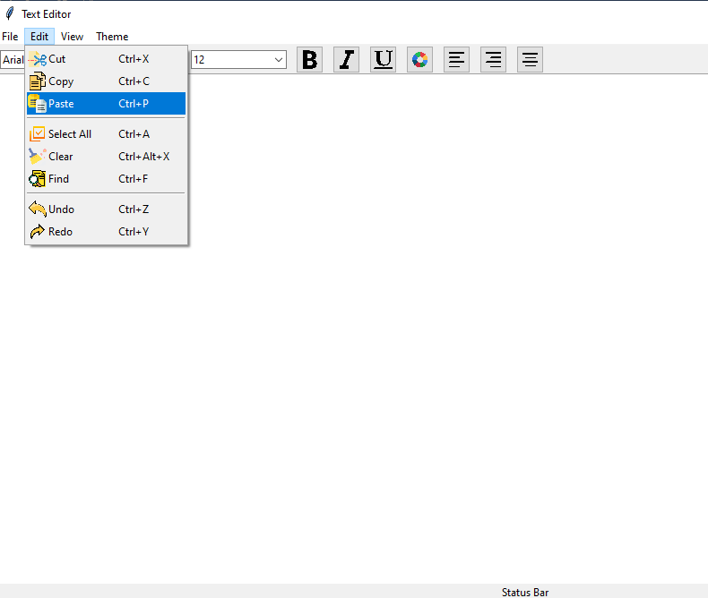

Figure 8 paste

### 1.3.2.4 **Undo**

This function allows the user to undo the last action performed, whether it was typing, deleting, or other modifications to the document. Multiple undos are usually available.

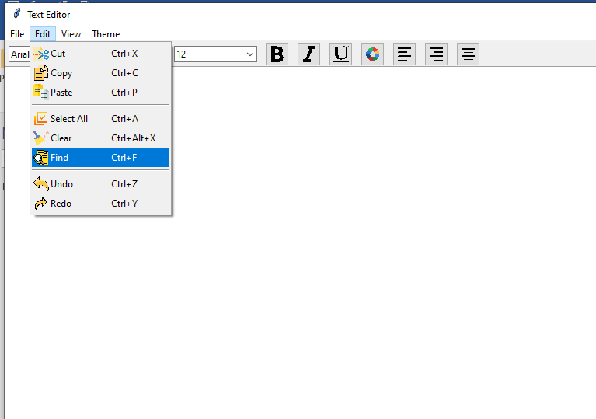

Figure 9 Undo

### 1.3.2.5 **Redo**

Redo reverses the last undo operation. If the user undoes a change by mistake, they can quickly redo it to restore the original state

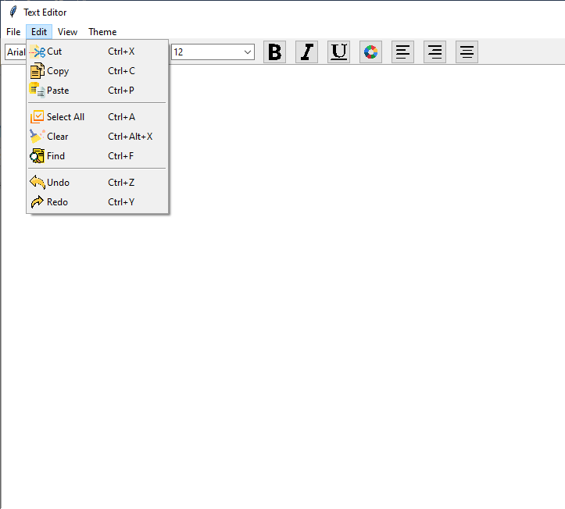

Figure 10 Redo

### 1.3.2.6 **Select All**

This command selects all the content in the document, allowing the user to perform actions such as copying, cutting, or formatting on the entire text.

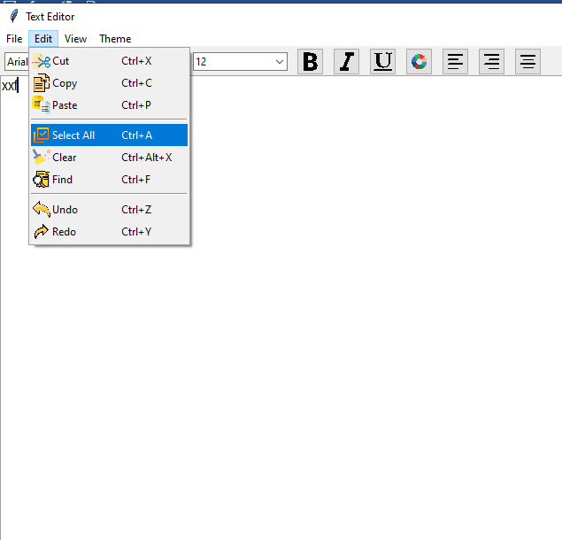

Figure 11 Selecting All

### 1.3.2.7 **Clear**

Clears the selected text or content from the document, similar to deleting it. It doesn't remove the content from the clipboard, so the user can paste it later if desired.

### 1.3.2.8 **Find**

The "Find" function lets the user search for specific text within the document. This is helpful for quickly locating words, phrases, or patterns within large documents.

### 1.3.3 **View Menu Functions**

### 1.3.3.1 **View Status Bar**

The "Status Bar" displays relevant information about the document, such as the current page number, word count, and the cursor’s position within the text. This option allows users to toggle the visibility of the status bar, enabling them to either keep it visible for constant reference or hide it to maximize the workspace area. It provides an overview of essential metrics and feedback while working on the document.

### 1.3.3.2 **View Menu Bar**

The "Menu Bar" is a horizontal bar at the top of the window containing essential commands like File, Edit, View, and others, giving users quick access to various features of the text editor. This option enables users to toggle the visibility of the menu bar, which is especially helpful for maximizing the document view and using a more streamlined interface, especially when working with larger screens or when focusing on the content itself.

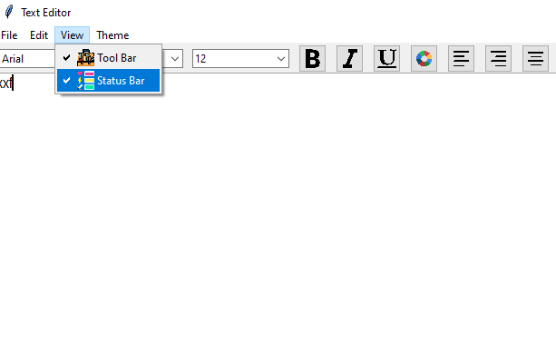

Figure 12 View bar

## Status Bar:

* + - 1. Count Number of Words:

The word count feature provides the total number of words in the document. This is essential for writers, researchers, or students working on assignments with word limits.

* + - 1. Count Number of Characters:

This option counts and displays the number of characters (with or without spaces) in the document. It's helpful for tasks requiring character limits, such as social media posts or coding.



Figure 13 STATUS BAR

# Component Details:

## 1.4.1 File Menu:

|  |  |  |
| --- | --- | --- |
| **Option** | **Description** | **Functionality** |
| New File | Creates a new blank document | Clears the editor |
| Open File | Opens an existing document | Load file content |
| Save File | Saves current document | Save current state |
| Save As | Saves under a new name/location | File duplication |
| Exit | Closes the application | Prompts for saving |

Tbl No. 1

## 1.4.2 Edit Menu:

|  |  |  |
| --- | --- | --- |
| **Option** | **Description** | **Functionality** |
| Cut | Removes selected text | Copy & delete |
| Copy | Copies selected text | Duplicate text |
| Paste | Inserts copied text | Text insertion |
| Undo | Reverts last action | Action reversal |
| Redo | Reapplies last undone action | Restore undone task |

Tbl No. 2

## View Menu:

|  |  |  |
| --- | --- | --- |
| **Option** | **Description** | **Functionality** |
| Status Bar | Toggles status bar visibility | Displays stats |
| Menu Bar | Toggles menu bar visibility | UI customization |

Tbl no.3

## 1.4.4 Theme

|  |  |  |
| --- | --- | --- |
| **Option** | **Description** | **Functionality** |
| Light Theme | Sets a light background | Reduces eye strain |
| Dark Theme | Sets a dark background | Low-light comfort |

Tble no 4

|  |  |  |
| --- | --- | --- |
|  |  |  |
|  |  |  |
|  |  |  |

## **1.4.5 Text Area:**

|  |  |  |
| --- | --- | --- |
| **Feature** | **Description** | **Functionality** |
| Main Text Box | Core text editing space | Text entry/editing |
| Word Count | Displays number of words | Tracks progress |
| Character Count | Displays number of characters | Tracks length |

Tbl no. 5

# **1.5 Data Structures and Algorithms Implementation:**

## **1.5.1 Text Area - Binary Search Tree (BST):**

* **Purpose:** Efficient text storage and search
* **Why BST:**
  + Allows ordered storage of text lines.
  + Supports fast search, insertion, and deletion.

**Operations:**

* **Insert:** Adds new text lines.
* **Delete:** Removes specific lines.
* **Search:** Quickly finds text content.

## **1.5.2 Undo/Redo - Stack:**

* **Purpose:** Maintain action history for easy reversal.

**Why Stack:**

* Follows the Last In, First Out (LIFO) principle.

**Operations:**

* **Push:** Saves actions performed.
* **Pop:** Reverts the last action.
* **Redo Stack:** Re-applies previously undone actions.

## **1.5.3 Cut, Copy, Paste - Graph:**

* **Purpose:** Manage text relationships and dependencies.

**Why Graph:**

* Nodes represent text blocks.
* Edges track cut/copied text dependencies.

**Operations:**

* **Insert Edge:** Represents copying text.
* **Remove Edge:** Deletes links on paste.
* **Traversal:** Ensures correct text pasting order.

# **1.6. Future Improvements:**

* **Cloud Integration:** Enable cloud storage for easy file access.
* **Collaborative Editing:** Support real-time collaborative document editing.
* **Advanced Search:** Implement more complex search options using trie data structures.
* **Version Control:** Add file versioning for easy rollback.
* **Machine Learning:** Use ML for predictive text suggestions.
* **Language Support:** Extend language processing for grammar and spell checks.